DESIGN AND ANALYSIS OF ALGORITHMS LABORATORY
[As per Choice Based Credit System (CBCS) & OBE Scheme]
SEMESTER – IV
Course Code: |  | P21CSL406 | Credits: | 01
Teaching Hours/Week (L:T:P): |  | 0:0:2 | CIE Marks: | 50
Total Number of Lab Hours: |  | 24 | SEE Marks: | 50
Note: Implement the following programs using C Language
Experiments
1. | Print all the nodes reachable from a given starting node in a digraph using BFS method.
2. | Obtain the Topological ordering of vertices in a given digraph (DFS Based).
3. | Sort a given set of elements using Merge sort method and determine the time taken to sort the elements. Repeat the experiment for different values of n, the number of elements in the list to be sorted and plot a graph of the time taken versus n.
4. | Sort a given set of elements using Quick sort method and determine the time taken to sort the elements. Repeat the experiment for different values of n, the number of elements in the list to be sorted and plot a graph of the time taken versus n.
5. | Find the Pattern string in a given Text string using Horspool’s String Matching Algorithm.
6. | Sort a given set of elements using Heap Sort algorithm.
7. | Implement 0/1 Knapsack problem using Dynamic Programming.
8. | From a given vertex in a weighted connected graph, find shortest paths to other Vertices using Dijikstra’s algorithm.
9. | ` Find minimum cost spanning tree of a given undirected graph using Kruskal’s Algorithm.
10. | Implement Sum-of-Subset problem of a given set S = {s₁, s₂, ........., s_{n}} of ‘n’ Positive integers whose sum is equal to a given positive integer ‘d’.

Program 1:

Print all the nodes reachable from a given starting node in a digraph using BFS method.
Breadth first search
It is a method used to traverse the given graph (i.e, visiting all the vertices in the given graph exactly once).

Method:
  - It proceeds by visiting first all the vertices that are adjacent to a starting vertex, then all unvisited vertices two edges apart from it, and so on, until all the vertices in the same connected component as the starting vertex are visited.
  - If there still remain unvisited vertices, the algorithm has to be restarted at an arbitrary vertex of another connected component of the graph.

Procedure:
  - Queue is a convenient data structure to trace the operation of breadth-first search.
  - The queue is initialized with the traversal’s starting vertex.
  - Mark it as visited.
  - On each iteration, the algorithm identifies all unvisited vertices that are adjacent to the front vertex of the queue, mark them as visited, and add them to the queue.
  - Then remove the front vertex from the queue.

Algorithm for BFS traversal Algorithm BFS(G)
//Implements a breadth-first search traversal of a given graph
//Input: Graph G =V,E
//Output: Graph G with its vertices marked with consecutive integers in the order they are visited by the BFS traversal
mark each vertex in V with 0 as a mark of being “unvisited” count ← 0
for each vertex v in V do
if v is marked with 0
bfs(v)

Algorithm bfs(v)
//visits all the unvisited vertices connected to vertex v by a path and numbers them in the order they are visited via global variable count
count ← count + 1;
mark v with count and initialize a queue with v
while the queue is not empty do
for each vertex w in V adjacent to the front vertex do if w is marked with 0
count ← count + 1;
mark w with count add w to the queue
remove the front vertex from the queue

Applications:

  - To check connectivity of a graph.
  - To check acyclicity of a graph.
  - To find minimum edge path between two given vertices

/* C program to print all the nodes that are reachable from a given starting node in a digraph using BFS method*/
#include<stdio.h>
#include<conio.h>
int a[20][20],q[20],visited[20],n, i, j,f=0,r=-1;
void bfs(int v)
{
for(i=1;i<=n;i++)
if(a[v][i] && !visited[i])
q[++r]=i;
if(f<=r)
{
visited[q[f]]=1;
bfs(q[f++]);
}
}
void main()
{
int v; clrscr();
printf("\n Enter the number of vertices:"); scanf("%d",&n);
for(i=1;i<=n;i++)
{ q[i]=0;
visited[i]=0;
}
printf("\n Enter graph data in matrix form:\n"); for(i=1;i<=n;i++)
for(j=1;j<=n;j++) scanf("%d",&a[i][j]);
printf("\n Enter the starting vertex:"); scanf("%d",&v);
bfs(v);
printf("\n The node which are reachable are:\n"); for(i=1;i<=n;i++)
if(visited[i])
printf("%d\t",i); getch();
}

Input Graph:
Output:
1
2
3
4
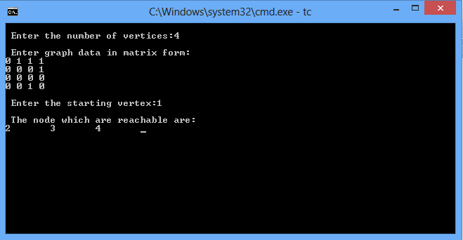
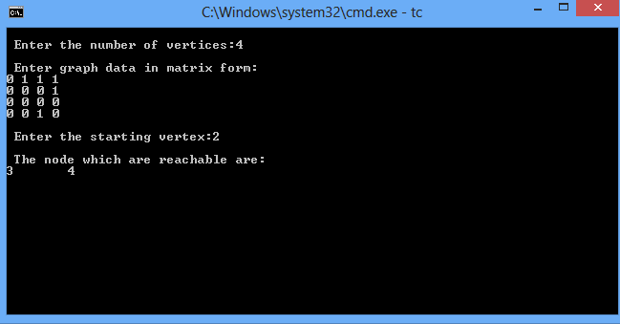

Program 2:
Obtain the Topological ordering of vertices in a given digraph (DFS Based).

Topological sorting for Directed Acyclic Graph (DAG) is a linear ordering of vertices such that for every directed edge u v, vertex u comes before v in the ordering.
Note: Topological Sorting for a graph is not possible if the graph is not a DAG.

Procedure:

Maintain two time stamps for each node where first time stamp represents the time at which the node is visited and the second represents the time at which the node becomes the dead end.
Start from the first vertex in the adjacency matrix of the given graph.i.e.,0
At time 1 we visit the node ‘0’ and at time 2 node 0 becomes dead end as there is no adjacent vertex to node ‘0’.

The next unvisited vertex in the matrix is node ‘1’ ,so at time ‘3’ node ‘1’ is visited and at time ‘4’ node ‘1’ becomes dead end as there is no adjacent vertex to node ‘1’.

The next unvisited vertex in the matrix is node ‘2’ ,so at time ‘5’ node ‘2’ is visited ,as there is adjacent vertex to node ‘2’ i.e.,node ‘3’ at time ‘6’ node ‘3’ is visited .There is a adjacent vertex node ‘1’ to node ‘3’ ,but it is already been visited and also since there are no adjacent vertices to node ‘3’,it becomes dead end at time 7.Get back to node 2 from which node 3 was visited .as there is no adjacent vertex to node 2,it becomes dead end at time 8.

The next unvisited vertex in the matrix is node ‘4’ .So at time 9 node 4 is visited , Though there are adjacent vertices ‘1’ and ‘0’ to node ‘4’ and they are already been visited, at time 10 node ‘4’ becomes dead end .

The next unvisited vertex in the matrix is node ‘5’ .So at time 11 node 5 is visited , Though there are adjacent vertices ‘2’ and ‘0’ to node ‘5’ and they are already been visited, at time 12 node ‘5’ becomes dead end .

Now as all the vertices have been visited, Arrange the nodes in decreasing order of their second time stamp, Then we obtain the topological sequence using DFS method.

Given graph is:
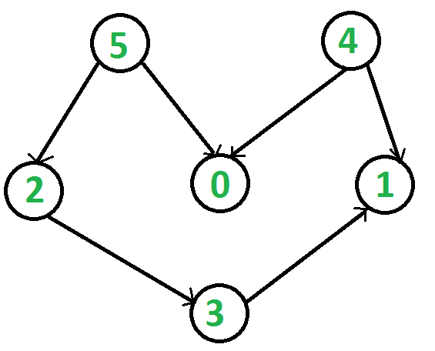

After applying the DFS traversal for the above graph,the resultant graphn will be as shown below:

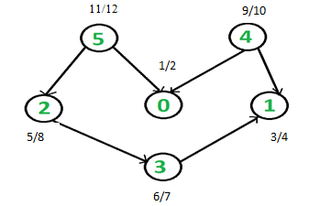

Arrange the nodes in descending order according to second time stamp

11/12 | 9/10 | 5/8 | 6/7 | 3/4 | 1/2
5 | 4 | 2 | 3 | 1 | 0

The topological sequence is: 5 4 2 3 1 0

#include<stdio.h>

int res[20]; //store the dead vertex or which is completely explored
int s[20]; //to know what nodes are visited and what nodes are not visited
int j=0; //index variable for array res[]

void dfs(int u,int n,int cost[10][10])
{
int v;
//visit the vertex u
s[u]=1;
//traverse deeper into the graph till we get the dead end or till all the vertices are visited
for(v=0;v<n;v++)
{
if(cost[u][v]==1 && s[v]==0)
{
dfs(v,n,cost);
}
}
//store the dead vertex or which is completely explored
res[j++]=u;
}

void depth_first_traversal(int n,int a[10][10])
{
int i;
//initialisation to indicate that no vertex has been visited
for(i=0;i<n;i++)
s[i]=0;

//process each vertex in the graph
for(i=0;i<n;i++)
{
if(s[i]==0)
dfs(i,n,a);
}
}

void main()
{
int i,j,k,m,n,cost[10][10];
printf("\nEnter the number of nodes");
scanf("%d",&n);

printf("\nEnter the adjacency matrix:");
for(i=0;i<n;i++)
for(j=0;j<n;j++)
scanf("%d",&cost[i][j]);

depth_first_traversal(n,cost);

printf("\nThe topological sequence is:\n");
for(i=n-1;i>=0;i--)
printf("%d ",res[i]);
}

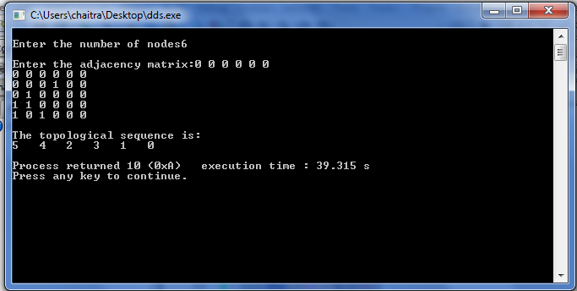
Program 3:
Sort a given set of elements using Merge sort method and determine the time taken to sort the elements. Repeat the experiment for different values of n, the number of elements in the list to be sorted and plot a graph of the time taken versus n.

Mergesort
Algorithm Mergesort(A,low,high)
//Purpose:Sort the elements of the array between lower bound and upper bound
//Input: A-Unsorted array with low and high as lower bound and upper bound
//Output: A is Sorted array

If(low<high)
Mid=(low+high)/2
Mergesort(A,low,mid)
Mergesort(A,mid+1,high)
Simplemerge(A,low,mid,high)
Mergesort is a perfect example of a successful application of the divide-and conquer technique. It sorts a given array A[0..n − 1] by dividing it into two halves A[0..n/2 − 1] and A[n/2..n− 1], sorting each of them recursively, and then merging the two smaller sorted arrays into a single sorted one.
Algorithm Mergesort(A,low,high)
//Purpose:Sort the elements of the array between lower bound and upper bound
//Input: A-Unsorted array with low and high as lower bound and upper bound
//Output: A is Sorted array
if(low<high)
Mid=(low+high)/2
Mergesort(A,low,mid)
Mergesort(A,mid+1,high)
SimpleMerge(A,low,mid,high)
end if

if(low<high)
1. Divide the array into two equal parts
2. Sort left part of the array recursively
3. Sort right part of the array recursively
4. Merge the left part and right part

The merging of two sorted arrays can be done as follows. Two pointers (array indices) are initialized to point to the first elements of the arrays being merged. The elements pointed to are compared, and the smaller of them is added to a new array being constructed; after that, the index of the smaller element is incremented to point to its immediate successor in the array it was copied from. This operation is repeated until one of the two given arrays is exhausted, and then the remaining elements of the other array are copied to the end of the new array.

Algorithm SimpleMerge(A,low,mid,high)
//Merges two sorted arrays where first array starts from low to mid and second array starts from mid+1 to high
//Input: Arrays A[0..mid] and A[mid+1…high] both sorted
//Output: Sorted array A[0..high]

i←low; j ←mid+1; k←low
while( i<=mid and j <=high)
if (A[i]≤ A[j]) then
C[k++]←A[i++];

else
C[k++]←A[j ++];
end if
end while
while(i<=mid)
C[k++]←A[i++];
while(j<=high)
C[k++]←A[j++];
For(i=0;i<n;i++)
A[i]=C[i]
Print Array A

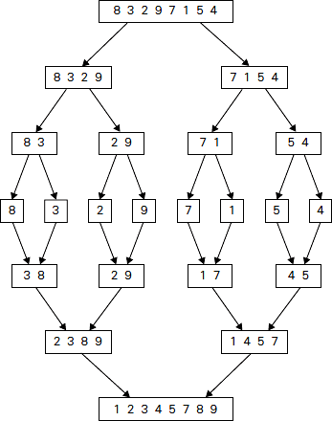
#include <stdio.h>
#include<time.h>
#include<stdlib.h>

int C[20];
void Merge(int a[ ], int low, int mid, int high)
{
int i, j, k;
i=low; j=mid+1; k=low;
while ( i<=mid && j<=high )
{
if( a[i] <= a[j] )
C[k++] = a[i++] ;
else
C[k++] = a[j++] ;
}
while (i<=mid)
C[k++] = a[i++] ;
while (j<=high)
C[k++] = a[j++] ;
for(k=low; k<=high; k++)
a[k] = C[k];
}

void MergeSort(int a[], int low, int high)
{
int mid;

if(low >= high)
return;
mid = (low+high)/2 ;
MergeSort(a, low, mid);
MergeSort(a, mid+1, high);
Merge(a, low, mid, high);
}

int main( )
{
int n, a[100],k;
clock_t st,et;
double ts;
printf("\n Enter the number of elements to be sorted:");
scanf("%d", &n);
srand(time(0));
printf("\nThe Random Numbers are:\n");
for(k=1; k<=n; k++)
{
a[k]=rand()% 100;
printf("%d\t", a[k]);
}
st=clock();
MergeSort(a, 1, n);
et=clock();
ts=(double)(et-st)/CLK_TCK;
printf("\n\n\n Sorted Numbers are : \n ");
for(k=1; k<=n; k++)
{
printf("%d\t", a[k]);
}
printf("\nThe time taken is %e",ts);
return 0;
}

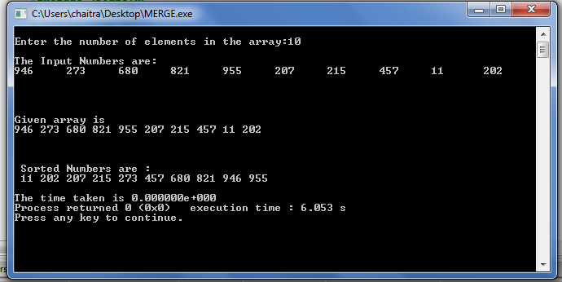

Program 4:

Sort a given set of elements using Quick sort method and determine the time taken to sort the elements. Repeat the experiment for different values of n, the number of elements in the list to be sorted and plot a graph of the time taken versus n.

Quick sort

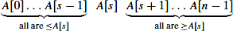
Quicksort is the other important sorting algorithm that is based on the divide-and conquers approach. Unlike mergesort, which divides its input elements according to their position in the array, quicksort divides them according to their value. A partition is an arrangement of the array’s elements so that all the elements to the left of some element A[s] are less than or equal to A[s], and all the elements to the right of A[s] are greater than or equal to it:
Obviously, after a partition is achieved, A[s] will be in its final position in the sorted array, and we can continue sorting the two subarrays to the left and to the right of A[s] independently (e.g., by the same method). Note the difference with mergesort: there, the division of the problem into two subproblems is immediate and the entire work happens in combining their solutions; here, the entire work happens in the division stage, with no work required to combine the solutions to the subproblems.

Algorithm Quicksort(A[low..high])
//Sorts a subarray by quicksort
//Input: Subarray of array A[0..n − 1], defined by its left and right indices low and high
//Output: Subarray A[low..high] sorted in non decreasing order
if (low<high)
mid←Partition(A[low..high]) //mid is a partitioned position Quicksort(A[low..mid-1])
Quicksort(A[mid+1 ..high])
We can partition A[0..n − 1] and, more generally, its sub array A[low..high] (0 ≤ low < high≤ n − 1) by the more sophisticated method suggested by C.A.R. Hoare, the prominent British computer scientist who invented quicksort.
Algorithm Partition(a[low..high])
//Partitions a sub array using the first element as a pivot
//Input: Sub array of array a[0..n − 1], defined by its left and right indices low and high (low<high)
//Output: Partition of A[low..high], with the split position returned as this function’s value
Key

key=a[low];
i=low; j=high+1;
while(i<=j)
do i←i+1 while(key>=a[i]);
do j←j+ while(key<a[j]);

if(i<j) exchange(a[i], a[j])
end while

exchange(a[j], a[low]);
return j;
}

Program:

#include<stdio.h>
#include<time.h>
#include<stdlib.h>

int partition(int a[], int low, int high)
{
int i, j, key,temp;

key=a[low];
i=low; j=high+1;
while(i<=j)
{
do
{
i++;
}while(key>=a[i]);

do
{
j--;
}while(key<a[j]);

if(i<j)
{
//swap the elements in position i and j
temp=a[i];
a[i]=a[j];
a[j]=temp;
}
}
//swap key element with element in position 'j'
temp=a[low];
a[low]=a[j];
a[j]=temp;
return j;
}

void quick_sort(int a[],int low,int high)
{
int mid;
if(low<high)
{
mid=partition(a,low,high);
quick_sort(a,low,mid-1);
quick_sort(a,mid+1,high);
}
}

int main()
{
int n, a[100],k;
clock_t st,et;
double ts;
printf("\n Enter How many Numbers: ");
scanf("%d", &n);
srand(time(0));
printf("\nThe Random Numbers are:\n");
for(k=0; k<n; k++)
{
a[k]=rand()%100;
printf("%d\t",a[k]);
}
st=clock();
quick_sort(a, 0, n-1);
et=clock();
ts=(double)(et-st)/CLK_TCK;
printf("\n\n\nSorted Numbers are: \n ");
for(k=0; k<n; k++)
printf("%d\t", a[k]);
printf("\nThe time taken is %e",ts);
}

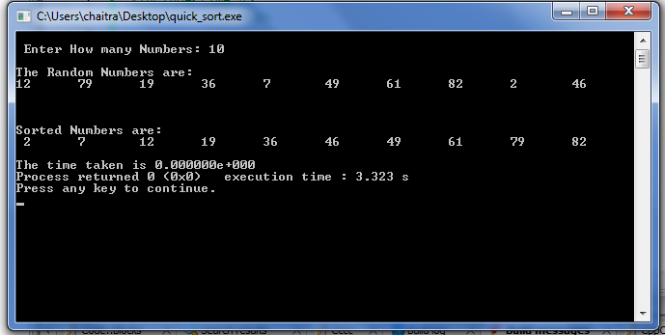

Program 5

Find the Pattern string in a given Text string using Horspool’s String Matching Algorithm.

In computer science, approximate string matching is the technique of finding strings that match a pattern approximately (rather than exactly).

Horspool's Algorithm
Horspool's algorithm shifts the pattern by looking up shift value in the character of the text aligned with the last character of the pattern in table made during the initialization of the algorithm. The pattern is check with the text from right to left and progresses left to right through the text.

Let c be the character in the text that aligns with the last character of the pattern. If the pattern does not match there are 4 cases to consider.
The mismatch occurs at the last character of the pattern:
Case 1: c does not exist in the pattern (Not the mismatch occurred here) then shift pattern right by the size of the pattern.

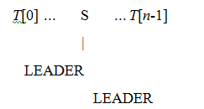

Case 2: The mismatch happens at the last character of the pattern and c exists in the pattern then the shift should be to the right most c in the m-1 remaining characters of the pattern.
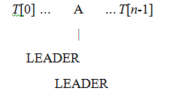

The mismatch happens in the middle of the pattern:
Case 3: The mismatch happens in the middle (therefore c is in pattern) and there are no other c in the pattern then the shift should be the pattern length.
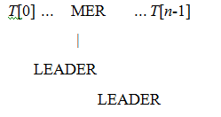

Case 4: The mismatch happens in the middle of the pattern but there is other c in pattern then the shift should be the right most c in the m-1 remaining characters of the pattern.
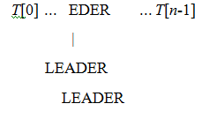

The table of shift values, table(c), is a table of the entire alphabet of the text and should give
t(c) = m if c is not in the first m-1 characters of the pattern
t(c) = distance of the right most c in the first m-1 characters of the pattern
To make the shift table we initialize the table to m and then scan the pattern left to right writing m-1- j in for the j character in the pattern.

Algorithm ShiftTable(P[0...m-1])
// output Table the size of the alphabet
// and gives the amount to shift the table. initialize all entries of Table to m
for j ← 0 to m-2 do Table[P[j]] ← m-1-j // character position from end of pattern
return Table

- The line for j ← 0 to m-2 do Table[P[j]] ← m-1-j Finds the right most location in the pattern of the character

Algorithm HorspoolMatching(P[0...m-1], T[0...n-1]) Table ← ShiftTable(P[0...m-1])
i ← m-1 // index for text aligned with the last character of the pattern
while i ≤ n-1 do
k ← 0 // matching index
while k ≤ m-1 and P[m-1-k]==T[i-k] // check matching
do
k++
if (k = m)
then
return i-m+1 // Match
else i ← i + Table[T[i]] // Shift the pattern from left to right
return -1

#include<stdio.h>
#include<string.h>
#include<stdlib.h>

void shift_table(char p[],int t[])
{
int i,m;
/*length of pattern string*/
m=strlen(p);
/*initialize the table with pattern length*/
for(i=0;i<128;i++)
t[i]=m;
/*find the distance of the first m-1 characters of the string from the last character*/
for(i=0;i<=m-2;i++)
{
t[p[i]]=m-i-1;
}

}

int horspool_pattern_match(char p[],char t[])
{
int m,n,i,k,s[256];
shift_table(p,s);

m=strlen(p);
n=strlen(t);
i=m-1;

while(i<=n-1)
{
k=0;
while(k<=m-1 && t[i-k]==p[m-1-k])
{
k=k+1;
}
/*pattern found*/
if(k==m) return i-m+1;
/*No match,so shift the pattern towards right*/
i=i+s[t[i]];
}
return -1;
}

void main()
{
char p[50],t[100];
int pos;

printf("\nEnter the text string:\n");
scanf("%s",t);

printf("\nEnter the pattern string:\n");
scanf("%s",p);

pos=horspool_pattern_match(p,t);

if(pos==-1)
{
printf("\nPattern string not found\n");
exit(0);
}
printf("\nPattern string found at position %d\n",pos+1);
}

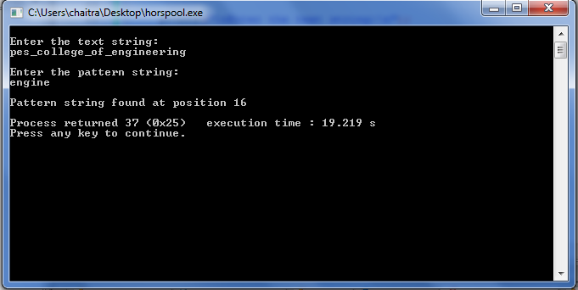

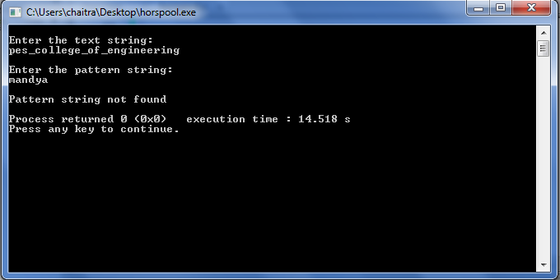

Program 6:
Sort a given set of elements using Heap Sort algorithm.

A heap is a complete binary tree or an almost complete binary tree satisfying the parental dominance requirement (i.e., each item in the tree should be greater than their children or each item in the tree should be less than their children.)
A heap can be used to sort the numbers in ascending or descending order. This sorting technique which uses heap to arrange numbers in ascending/descending order is called heap sort.
The main advantage of this technique is that sorting can easily be implemented using arrays.
This sorting technique consists of two phases namely:
- Heap creation phase
- Delete root item and recreate the heap

Heap creation phase:

In heap creation phase, the unsorted array is transformed into heap and this process is called hepifying the array. If we want the items to be in ascending order it is required to construct the max-heap (root node contains highest value). If we want the items to be in descending order it is required to construct the min-heap (root node contains lowest value).

Sorting Phase:
In this phase, items are arranged in ascending order (if we use max heap) or descending order (if we use min heap).This is achieved by repeatedly performing the following activities.
- Exchange the root item to the end of the heap
- Decrement the size of the heap by 1 and recreate the heap by using the bottom_up_heapify()
Pseudo code for these two steps:
Exchange (a[0],a[i])
Bottom_up_heapify (i, a, 0);

Heap Sort Algorithm using Bottom up approach:

Algorithm heapsort (n,a[])
//purpose: To sort the items using heap
//Input: a-the items to be arranged using sorting technique
n-the number of items to be sorted.
//Output: a-Contains the sorted list

[create the heap]
for(i←(n-1)/2 down to 0)
heapify (n,a,i)
end for
[Repeatedly exchange and recreate the heap]
for(i←n-1 down to 0)
Exchange (a[0],a[i])
Bottom_up_heapify (i, a, 0);
end for
[The items are sorted and terminate the algorithm]

return

#include<stdio.h>
#include<conio.h>
void heapify(int a[],int n)
{
int i,j,k,item;
for(k=1;k<n;k++)
{
item=a[k];
i=k;
j=(i-1)/2;
while(i>0 && item>a[j])
{
a[i]=a[j];
i=j;
j=(i-1)/2;
}
a[i]=item;
}

}

void adjust(int a[],int n)
{
int i,j,item;
j=0;
item=a[j];
i=2*j+1;
while(i<=n-1)
{
if(i+1<=n-1)
if(a[i]<a[i+1])
i++;
if(item<a[i])
{
a[j]=a[i];
j=i;
i=2*j+1;
}
else
break;
}
a[j]=item;
}

void heapsort(int a[],int n)
{
int i,temp;
heapify(a,n);
for(i=n-1;i>0;i--)
{
temp=a[0];
a[0]=a[i];
a[i]=temp;
adjust(a,i);
}
}

void main()
{
int a[20],n,temp,i;
printf("enter the number of elements to sort\n");
scanf("%d",&n);
printf("enter elements to sort\n");
for(i=0;i<n;i++)
scanf("%d",&a[i]);
heapsort(a,n);
printf("the sorted array is\n");
for(i=0;i<n;i++)
{
printf("%d\t",a[i]);
}
}

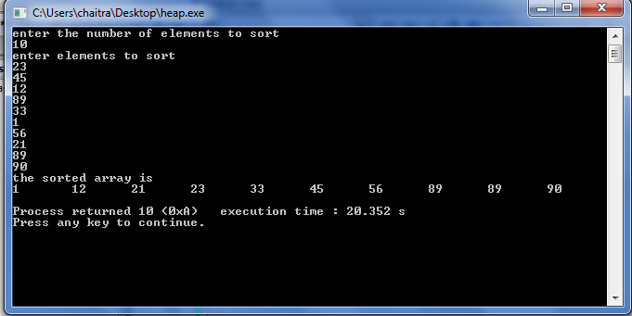

Program 7:
Implement 0/1 Knapsack problem using Dynamic Programming.

In this problem we are given a knapsack of capacity M and ‘n’ objects of weights w1,w2,.......wn withnprofits p1,p2,...........pn.The main objective is to place the objects into knapsack so that maximum profit is obtained and the weights od the objects chosen should not exceed the capacity of the knapsack.

The recurrence relation to get the solution to the knapsack problem can be written as shown below:

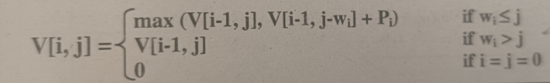

#include<stdio.h>
int max(int a,int b)
{
return a>b?a:b;
}

void knapsack(int n,int w[],int m,int v[][10],int p[])
{
int i,j;

for(i=0;i<=n;i++)
{
for(j=0;j<=m;j++)
{
if(i==0||j==0)
v[i][j]=0;
else if(j<w[i])
v[i][j]=v[i-1][j];
else
v[i][j]=max(v[i-1][j],v[i-1][j-w[i]]+p[i]);

}
}
}

void print_optimal_sol(int n,int m,int w[],int v[10][10])
{
int i,j,x[10];
printf("\nThe optimal solution is %d:\n",v[n][m]);
/*Initially no object is selected*/

for(i=0;i<n;i++)
x[i]=0;
i=n; /*number of objects*/
j=m;/*capacity of knapsack*/

while(i!=0 && j!=0)
{
if(v[i][j]!=v[i-1][j])
{
x[i]=1;
j=j-w[i];
}
i=i-1;
}
/*output the objects selected*/

for(i=1;i<=n;i++)
{
printf("x[%d]",i);
}
printf("=");
for(i=1;i<=n;i++)
{
printf("%d ",x[i]);
}
}

void main()
{
int m,n,i,j;
int p[10];
int w[10],v[10][10];
clrscr();
printf("\n Enter the number of objects\n");
scanf("%d",&n);
printf("\nEnter the weights of n objects:");
for(i=1;i<=n;i++)
scanf("%d",&w[i]);
printf("Enter the profits of n objects\n");
for(i=1;i<=n;i++)
scanf("%d",&p[i]);

printf("\nEnter the capacity of knapsack\n");
scanf("%d",&m);

knapsack(n,w,m,v,p);

printf("The output is\n");
for(i=0;i<=n;i++)
{
for(j=0;j<=m;j++)
{
printf("%d ",v[i][j]);
}
printf("\n");
}
print_optimal_sol(n,m,w,v);
}

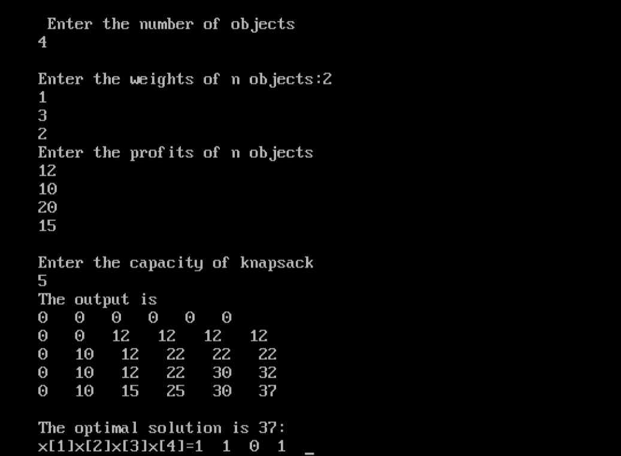

Program 8:
From a given vertex in a weighted connected graph, find shortest paths to other Vertices using Dijikstra’s algorithm.
Dijkstra's Algorithm (Single-Source Shortest Path Problem)
Method: For a given vertex called the source in a weighted connected graph, find shortest paths to all its other vertices. The single-source shortest-paths problem asks for a family of paths, each leading from the source to a different vertex in the graph, though some paths may, of course, have edges in common.
In other words, given a graph G = (V, E) and a source vertex vs, we find the shortest distance from vs to every other vertex vd in V.
This algorithm is applicable to undirected and directed graphs with nonnegative weights only.
This method is based on Greedy Technique.

Algorithm:

1. Read source vertex
2. Mark source vertex as visited
3. Initialize distance matrix d[ ] with sourceth row elements from the cost adjacency matrix
4. Find u and d[u] such that d[u] is minimum and uϵV-S
5. Add u to S
6. for every v which is not in S (i.e, v ϵV-S)
Find d[v] = min(d[v], d[u]+cost[u][v])
end for
7. repeat step 4 through 6 for remaining n-1 vertices

#include<stdio.h>
#include<conio.h>
int cost[10][10],d[10], p[10], n;
void dij(int source,int dest)
{
int i,j,u,v,min,S[10];
for(i=0;i<n;i++)
{
d[i]=cost[source][i];
S[i]=0;
p[i]=source;
}
S[source]=1;
for(i=1;i<n;i++)
{
min=999;
u=-1;
for(j=0;j<n;j++)
{
if(d[j]<min &&S[j]==0)
{
min=d[j];
u=j;
}
}
if(u==-1)
return;
S[u]=1;
if(u==dest)
return;
for(v=0;v<n;v++)
{
if((d[u]+cost[u][v]<d[v]) &&S[v]==0)
{
d[v]=d[u]+cost[u][v];
p[v]=u;
}
}
}
}

void print_path(int source)
{
int destination,i;
for(destination=0;destination<n; destination++)
{
dij(source,destination);
if(d[destination]==999)
printf("\n %d is not reachable from %d",destination,source);
else
{
printf("\nThe shortest path from source to every other vertices are:\n");
i=destination;
while(i!=source)
{
printf("%d <-- ",i);
i=p[i];
}
printf("%d=%d\n",i, d[destination]);
}
}
}

void main()
{
int i,j,source;
//clrscr();
printf("\n Enter the number of nodes:");
scanf("%d",&n);
printf("\n Enter the cost adjacency matrix:\n");
for(i=1;i<=n;i++)
{
for(j=1;j<=n;j++)
{
scanf("%d",&cost[i][j]);
}
}
printf("\n Enter the source Vertex:");
scanf("%d",&source);
print_path(source);
getch();
}Input Graph:

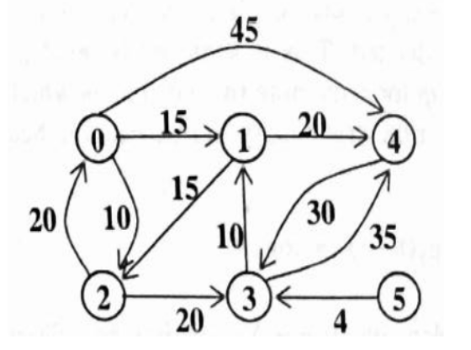

OUTPUT
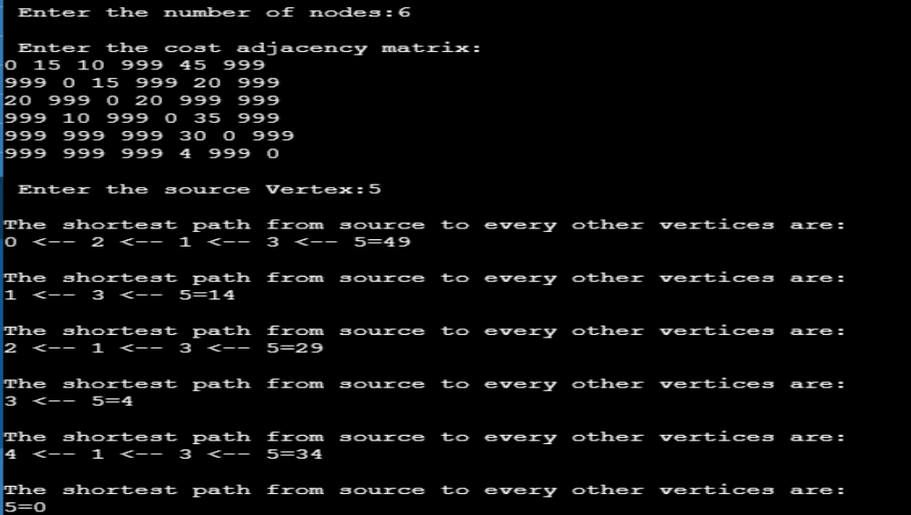
Problem 9:
Find minimum cost spanning tree of a given undirected graph using Kruskal’s Algorithm.

Method: Kruskal's algorithm is a greedy algorithm that finds a minimum spanning tree for a connected weightedgraph.It finds a subset of the edges that forms a tree that includes every vertex,where the total weight of all the edges in the tree is minimized.
Let G=(V,E) be a directed graph. The algorithm selects n-1 edges one at a time. The algorithm selects the least cost edge (u,v) from E and delete the edge (u,v) from E. Then it checks whether the selected edge results in cycle when added to the list of edges to form MST. If the selected edge (u, v) does not form cycles, then it isadded to the list of edges to form MST else the edge is neglected. This process is repeated until n-1 edges are selected.

Two functions which are essential for the design of Kruskal’s algorithm are:

1. find(u): if u is a node in a tree, this function returns the root of the corresponding tree.

2. Union_ij(i, j): let C1 and C2 be two trees. If i is a vertex in tree C1 and j is a vertex in the tree C2, this function merges the two trees C1 and C2 into single tree.

Algorithm

1. Arrange the edges of the given graph in non-increasing order of their weights
2. Create a forest with n vertices
3. Select an edge(u,v) with least cost
4. Find the roots of vertex u and vertex v
5. If the roots of vertex u and vertex v are different then
Select the edge (u, v) as the edge of MST
Update the number of edges selected for MST
Update the cost of MST
Merge the two trees with roots of vertex u and vertex v
6. Delete the edge (u, v) from the list
7. Repeat steps 3 through 6 until n-1 edges are selected
8. Finally print the edges selected for MST along the cost

/*C Program to find Minimum Cost Spanning Tree of a given undirected graphusing Kruskal's algorithm. */
#include<stdio.h>
#include<conio.h>
#include<stdlib.h>
int cost[10][10],n;

int find(int node, int parent[10])
{
while(parent[node]!=node)
node=parent[node];
return node;
}

int union_ij(int i,int j,int parent[10])
{
if(i<j)
parent[j]=i;
else
parent[i]=j;
}

void kruskal_mst()
{
int count, i, parent[10], min, u, v, k, t[10][2], sum;
count=0,sum=0,k=0;
/* create a forest with n vertices*/
for(i=0;i<n;i++)
parent[i]=i;
/* repeat until n-1 edges are selected*/
while(count<n)
{
/* select an edge (u, v) with least cost*/
min=999;
for(i=0;i<n;i++)
{
for(j=0;j<n;j++)
{
if(cost[i][j]<min)
{
min=cost[i][j];
u=i;
v=j;
}
}
}
if(min==999)break;
/* find the roots of vertex u and vertex v*/
i=find(u,parent);
j=find(v,parent);
/*if the roots of vertex u and vertex v are different then*/
if(i!=j)
{
/*select the edge (u, v) as the edge of MST*/
t[k][0]=u;
t[k][1]=v;
k++;
/* update the number of edges selected for MST*/
count++;
/* update the cost of MST*/
sum=sum+min;
/* merge the two trees with roots of vertex u and vertex v*/
unioun_ij(i,j,parent);
}
/*delete the edge (u, v) from the list*/
cost[u][v]=cost[v][u]=999;
}
if(count==n-1)
{
printf("\nSpanning Tree Exists");
printf("\nThe cost of MST = %d",sum);
printf("\nSpanning tree is shown below:");
for(k=0;k<n-1;k++)
printf("\n%d-->%d",t[k][0],t[k][1]);
return;
}
else
printf("\nSpanning tree do not exist");
}

void main()
{
int i, j;
clrscr();
printf("\n\n\tImplementation of Kruskal's algorithm\n\n");
printf("\nEnter the no. of vertices\n");
scanf("%d",&n);
printf("\nEnter the cost adjacency matrix\n");
for(i=1;i<=n;i++)
{
for(j=1;j<=n;j++)
{
scanf("%d",&cost[i][j]);
if(cost[i][j]==0)
cost[i][j]=999;
}
}
kruskals_mst();
}

INPUT GRAPH
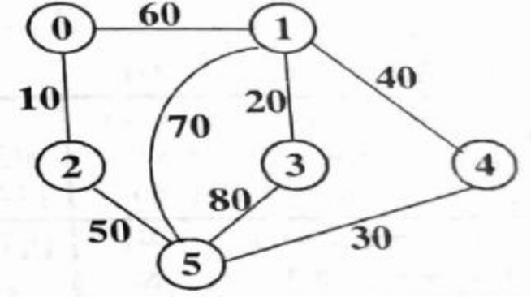
OUTPUT:

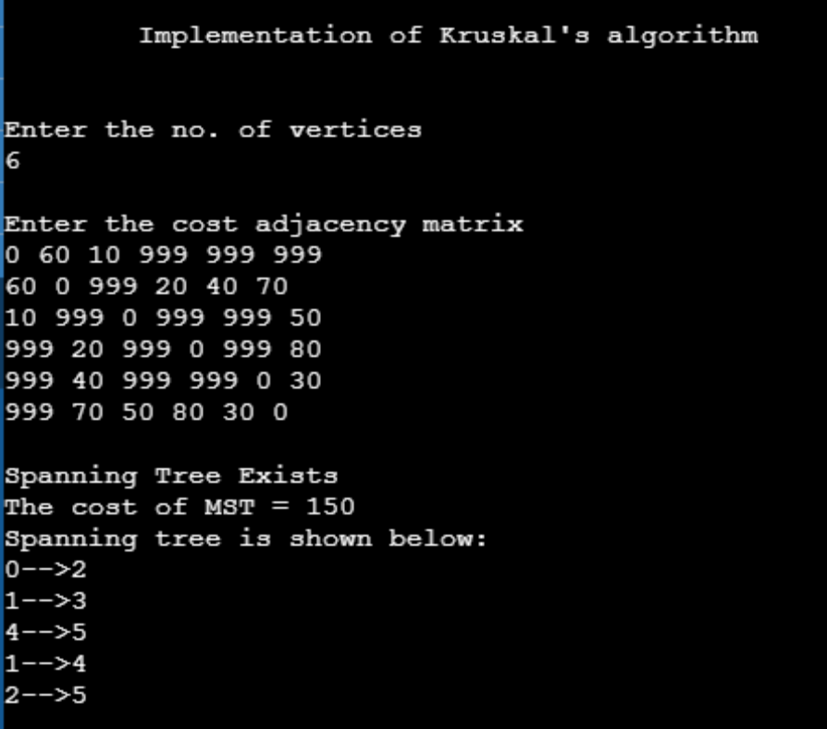

Program 10:
Implement Sum-of-Subset problem of a given set S = {s₁, s₂, ........., s_{n}} of ‘n’ Positive integers whose sum is equal to a given positive integer ‘d’.
In the subset sum problem, we have to find the subset of a set is such a way that the element of this subset-sum up to a given number K. All the elements of the set are positive and unique (no duplicate elements are present). For this, we will create subsets and check if their sum is equal to the given number k.
For example if S={1,2,5,6,8} and d=9,there are two solutions {1,2,6} and {1,8}.
#include<stdio.h>
int count=0;
int w[10];
int d;
int x[10];

void subset(int cs,int k,int r)
{
int i;
x[k]=1;
if(cs+w[k]==d)
{
printf("\nSubset solution=%d\n",++count);
for(i=0;i<=k;i++)
{
if(x[i]==1)
printf("%d ",w[i]);
}
}
else if(cs+w[k]+w[k+1]<=d)
subset(cs+w[k],k+1,r-w[k]);
if((cs+r-w[k]>=d)&&(cs+w[k+1]<=d))
{
x[k]=0;
subset(cs,k+1,r-w[k]);
}
}

void main()
{

int sum=0,i,n;
printf("\nEnter the number of elements\n");
scanf("%d",&n);

printf("\nEnter the elements in ascending order:\n");
for(i=0;i<n;i++)
scanf("%d",&w[i]);

printf("\nEnter the required sum:");
scanf("%d",&d);

for(i=0;i<n;i++)
sum+=w[i];

if(sum<d)
{
printf("\nNo solution exists\n");
return;
}
printf("\nThe solution is:\n");
subset(0,0,sum);
}

